Proposed WiFi Coverage

Phase 1 – Oxford City Centre

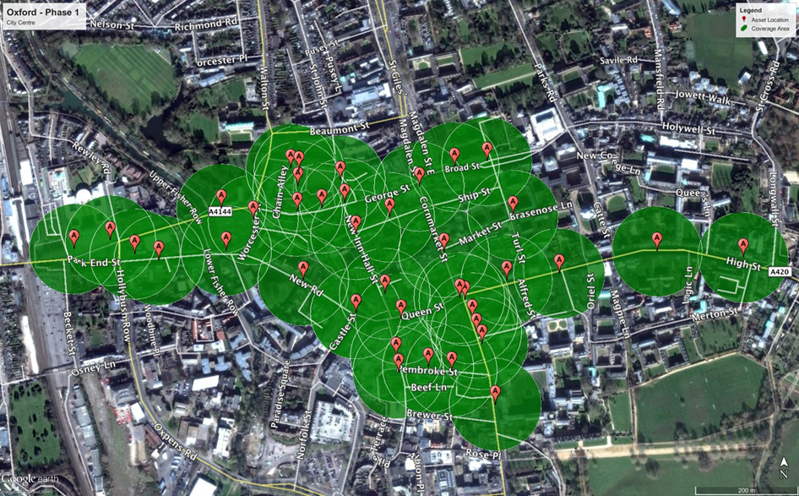

Phase 2 – Summertown, St Clements & Cowley Road
